Paper’s title should be the fewest possible words that accurately describe the content of the paper

(Palatino Linotype, Center, Bold, 14pt)

First Author^{1*}, Second Author², Third Author³ (10pt)
¹Affiliation, Faculty, University, City, Country (9 pt)
²Affiliation, Faculty, University, City, Country (9 pt)
³Affiliation, Faculty, University, City, Country (9 pt)
*Corresponding Author: authors@ft.unp.ac.id
*No. HP/Whatsapp: 0812 23 456789 *deleted after publishing

Article Information |  | ABSTRACT (10pt)
Article history:  No. 001  Rec. August 22, 1993  Rev. Month dd, yyyy  Acc. Month dd, yyyy  Pub. Month dd, yyyy  Page. 22 – 23 |  | A well-prepared abstract enables the reader to quickly and accurately identify the basic content of a document, determine its relevance to their interests, and thus decide whether to read the document in its entirety. The Abstract should be informative and self-explanatory, clearly state the problem and the proposed approach or solution, and point out major findings and conclusions. The Abstract should be 150 to 250 words in length. The abstract should be written in the past tense. Standard nomenclature should be used, and abbreviations should be avoided. No literature should be cited. The keyword list allows adding keywords used by the indexing and abstracting services and those already present in the title. Judicious use of keywords may increase the ease with which interested parties can locate our article (10 pt).
Keywords:
▪ First keyword
▪ Second keyword
▪ Third keyword
▪ Fourth keyword
▪ Fifth keyword
How to Cite:
Dwiyani, N., & Huda, Y. (2023). Android Application for Testing English Proficiency. Jurnal Teknologi Informasi Dan Pendidikan, 17(1), 1-13. https://doi.org/10.24036/jtip.v17i1.704
This open-access article is distributed under the Creative Commons Attribution-ShareAlike 4.0 International License, which permits unrestricted use, distribution, and reproduction in any medium, provided the original work is properly cited. ©2023 by Jurnal Teknologi Informasi dan Pendidikan.

- INTRODUCTION (11 pt)
The main text format is a flat left-right column on A4 paper (quarto). The margin text from the left and top are 2 cm, right and bottom are 2 cm. The manuscript is written in Microsoft Word, single space, Palatino Linotype 11 pt, and a maximum of 15 pages for the original research article, or a maximum of 18 pages for review/survey paper, which can be downloaded at the website: http://tip.ppj.unp.ac.id.
The article's title should be the fewest possible words accurately describing the paper's content. The title should be succinct, informative, and no more than about 12 words in length. Do not use acronyms or abbreviations in your title, and do not mention the method you used unless your paper reports on the development of a new method. Titles are often used in information retrieval systems. Avoid writing long formulas with subscripts in the title. Omit all waste words such as "A study of ...", "Investigations of ...", "Implementation of ... ", "Observations on ...", "Effect of ...", "Analysis of …", “Design of…", etc.
A concise and factual abstract is required. The abstract should briefly state the research's purpose, principal results, and major conclusions. An abstract is often presented separately from the article, so it must be able to stand alone. For this reason, References should be avoided, but if essential, cite the author(s) and year(s). Also, non-standard or uncommon abbreviations should be avoided, but if essential, they must be defined at their first mention in the abstract itself. Immediately after the abstract, provide a maximum of 7 keywords, using American spelling and avoiding general and plural terms and multiple concepts (avoid, for example, 'and', 'of'). Be sparing with abbreviations: only abbreviations firmly established in the field may be eligible. These keywords will be used for indexing purposes.
Indexing and abstracting services depend on the accuracy of the title, extracting from it keywords useful in cross-referencing and computer searching. An improperly titled paper may never reach the audience for which it was intended, so be specific.
The Introduction section should provide: i) a clear background, ii) a clear statement of the problem, iii) the relevant literature on the subject, iv) the proposed approach or solution, and v) the new value of research which it is innovation (within 3-6 paragraphs). It should be understandable to colleagues from a broad range of scientific disciplines. Organization and citation of the bibliography are made in the Institute of Electrical and Electronics Engineers (IEEE) style in sign [1], [2], and so on. The terms in foreign languages are written italics (italics). The text should be divided into sections, each with a separate heading and numbered consecutively [3]. The section or subsection headings should be typed on a separate line, e.g., 1. INTRODUCTION. A full article follows a standard structure: 1. Introduction, 2. The Comprehensive Theoretical Basis and the Proposed Method/Algorithm (Optional), 3. Method, 4. Results and Discussion, and 5. Conclusion. The structure is well-known as the IMRaD style.
In the literature review that has been done author used the section "INTRODUCTION" to explain the difference between the manuscript with other papers, that it is innovative, it are used in the section "RESEARCH METHOD" to describe the step of research and used in the section "RESULTS AND DISCUSSION" to support the analysis of the results [2]. If the manuscript was written have high originality, which proposed a new method or algorithm, the additional section after the "INTRODUCTION" section and before the "RESEARCH METHOD" section can be added to explain briefly the theory and/or the proposed method/algorithm [4].

- RESEARCH METHOD (11 pt)

Explaining research chronologically, including research design, research procedure (in the form of algorithms, Pseudocode, or other), how to test, and data acquisition [5]–[7]. The description of the course of research should be supported by references so the explanation can be accepted scientifically [2], [4]. Figures 1-2 and Table 1 are presented center (10 pt), as shown below and cited in the manuscript [5], [8]–[13]. Figure 2(a) shows single and ternary ion solutions. Figure 2(b) shows the electrolyte effect.

Figure 1. The image title is written in Sentence case (initially in capital letters)

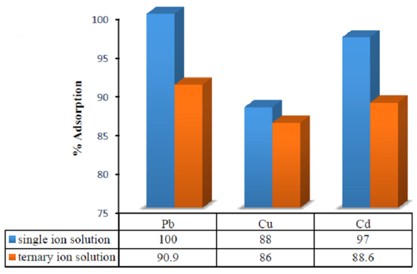 | 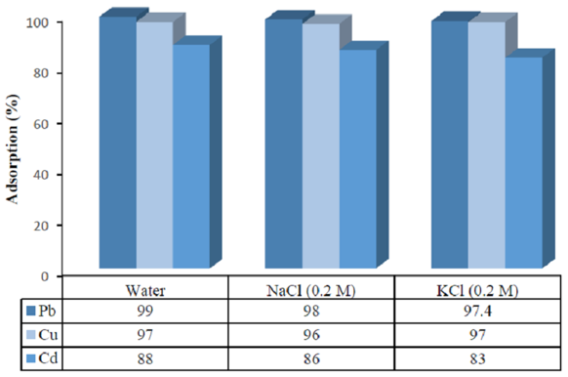
(a) | (b)
Figure 2. Selectivity of AC-SH for (a) single and ternary ions solution, (b) electrolyte effect

Table 1. The performance of ...
Variable | Speed (rpm) | Power (kW)
x | 10 | 8.6
y | 15 | 12.4
z | 20 | 15.3

- RESULTS AND DISCUSSION (11 pt)

This section explains the research results and, at the same time, a comprehensive discussion. Results can be presented in figures, graphs, tables, and others that make the reader understand easily [14], [15]. The discussion can be made in several sub-sections.

3.1. Sub-section 1

Equations should be placed at the center of the line and provided consecutively with equation numbers in parentheses flushed to the right margin, as in (1). The use of Microsoft Equation Editor or MathType is preferred.

$E_{v}-E=\frac{h}{2.m} (k_{x}^{2}+k_{y}^{2}$) (1)

All symbols used in the equations should be defined in the following text.

  - Sub-section 2

Proper citation of other works should be made to avoid plagiarism. When referring to a reference item, please use the reference number as in [16] or [17] for multiple references. The use of ”Ref [18]...” should be employed for any reference citation at the beginning of a sentence. For any reference with more than 3 or more authors, only the first author will be written, followed by et al. (e.g. in [19]). Examples of reference items of different categories are shown in the References section. Each item in the references section should be typed using a 9-point font size [20]–[25].

    - Subsub section 1

…
    - Subsub section 2

…

- CONCLUSION (11 pt)

Provide a statement that what is expected, as stated in the "INTRODUCTION" section, can ultimately result in the "RESULTS AND DISCUSSION" section, so there is compatibility. Moreover, it can also be added the prospect of the development of research results and application prospects of further studies into the next (based on result and discussion).

ACKNOWLEDGEMENTS (11 Pt – optional)

Author, thanks .... In most cases, sponsor and financial support acknowledgments.

REFERENCES (11 pt)

The main references are international journals and proceedings. All references should be to the most pertinent, up-to-date sources and the minimum of references is 15 entries (for original research paper) and 30 entries (for review/survey paper). References are written in IEEE style. For more complete guide can be accessed at (http://ipmuonline.com/guide/refstyle.pdf). Use of a tool such as EndNote, Mendeley, or Zotero for reference management and formatting, and choose IEEE style. Please use a consistent format for reference examples (font-size: 9 pt):

- Journal/Periodicals
Basic Format:
J. K. Author, “Title of paper,” Abbrev. Title of Journal/Periodical, vol. x, no. x, pp. xxx-xxx, Abbrev. Month, year, doi: xxx.
Examples:
- M. M. Chiampi and L. L. Zilberti, “Induction of electric field in human bodies moving near MRI: An efficient BEM computational procedure,” IEEE Trans. Biomed. Eng., vol. 58, pp. 2787–2793, Oct. 2011, doi: 10.1109/TBME.2011.2158315.
- R. Fardel, M. Nagel, F. Nuesch, T. Lippert, and A. Wokaun, “Fabrication of organic light emitting diode pixels by laser-assisted forward transfer,” Appl. Phys. Lett., vol. 91, no. 6, Aug. 2007, Art. no. 061103, doi: 10.1063/1.2759475.

- Conference Proceedings
Basic Format:
J. K. Author, “Title of paper,” in Abbreviated Name of Conf., (location of conference is optional), year, pp. xxx–xxx, doi: xxx.
Examples:
- G. Veruggio, “The EURON roboethics roadmap,” in Proc. Humanoids ’06: 6th IEEE-RAS Int. Conf. Humanoid Robots, 2006, pp. 612–617, doi: 10.1109/ICHR.2006.321337.
- J. Zhao, G. Sun, G. H. Loh, and Y. Xie, “Energy-efficient GPU design with reconfigurable in-package graphics memory,” in Proc. ACM/IEEE Int. Symp. Low Power Electron. Design (ISLPED), Jul. 2012, pp. 403–408, doi: 10.1145/2333660.2333752.

- Book
Basic Format:
J. K. Author, “Title of chapter in the book,” in Title of His Published Book, X. Editor, Ed., xth ed. City of Publisher, State (only U.S.), Country: Abbrev. of Publisher, year, ch. x, sec. x, pp. xxx–xxx.
Examples:
- A. Taflove, Computational Electrodynamics: The Finite-Difference Time-Domain Method in Computational Electrodynamics II, vol. 3, 2nd ed. Norwood, MA, USA: Artech House, 1996.
- R. L. Myer, “Parametric oscillators and nonlinear materials,” in Nonlinear Optics, vol. 4, P. G. Harper and B. S. Wherret, Eds., San Francisco, CA, USA: Academic, 1977, pp. 47–160.
- M. Theses (B.S., M.S.) and Dissertations (Ph.D.)
Basic Format:
J. K. Author, “Title of thesis,” M.S. thesis, Abbrev. Dept., Abbrev. Univ., City of Univ., Abbrev. State, year.
J. K. Author, “Title of dissertation,” Ph.D. dissertation, Abbrev. Dept., Abbrev. Univ., City of Univ., Abbrev. State, year.
Examples:
- J. O. Williams, “Narrow-band analyzer,” Ph.D. dissertation, Dept. Elect. Eng., Harvard Univ., Cambridge, MA, USA, 1993.
- N. Kawasaki, “Parametric study of thermal and chemical nonequilibrium nozzle flow,” M.S. thesis, Dept. Electron. Eng., Osaka Univ., Osaka, Japan, 1993.

*In the reference list, however, list all the authors for up to six authors. Use et al. only if: 1) The names are not given and 2) List of authors more than 6. Example: J. D. Bellamy et al., Computer Telephony Integration, New York: Wiley, 2010.

See the examples:
REFERENCES

[1] T. S. Ustun, C. Ozansoy, and A. Zayegh, “Recent developments in microgrids and example cases around the world—A review,” Renew. Sustain. Energy Rev., vol. 15, no. 8, pp. 4030–4041, Oct. 2011, doi: 10.1016/j.rser.2011.07.033.
[2] D. Salomonsson, L. Soder, and A. Sannino, “Protection of Low-Voltage DC Microgrids,” IEEE Trans. Power Deliv., vol. 24, no. 3, pp. 1045–1053, Jul. 2009, doi: 10.1109/TPWRD.2009.2016622.
[3] S. Chakraborty and M. G. Simoes, “Experimental Evaluation of Active Filtering in a Single-Phase High-Frequency AC Microgrid,” IEEE Trans. Energy Convers., vol. 24, no. 3, pp. 673–682, Sep. 2009, doi: 10.1109/TEC.2009.2015998.
[4] S. A. Hosseini, H. A. Abyaneh, S. H. H. Sadeghi, F. Razavi, and A. Nasiri, “An overview of microgrid protection methods and the factors involved,” Renew. Sustain. Energy Rev., vol. 64, pp. 174–186, Oct. 2016, doi: 10.1016/j.rser.2016.05.089.
[5] S. Chen, N. Tai, C. Fan, J. Liu, and S. Hong, “Sequence‐component‐based current differential protection for transmission lines connected with IIGs,” IET Gener. Transm. Distrib., vol. 12, no. 12, pp. 3086–3096, Jul. 2018, doi: 10.1049/iet-gtd.2017.1507.

