Virtual Build Design of Simulator Soldering

Ahmaddul Hadi ¹, Muhammad Zuharmando Ghaffara², Noval Yusri Yandi³, Khairi Budayawan⁴, Bayu Ramadhani Fajri⁵
^{1,2,3,4,5}Pendidikan Teknik Informatika, Universitas Negeri Padang, Indonesia
*Corresponding Author: dulhadi@ft.unp.ac.id

INTISARI
Perangkat elektronik yang digunakan manusia seringkali mengalami kerusakan. solder adalah solusi untuk memperbaiki perangkat elektronik. Jika seseorang ingin belajar menggunakan solder secara mandiri, alternatifnya yaitu dengan menonton video tutorial, bila dipraktekkan tanpa pengawasan cukup berbahaya dan ini berdampak langsung pada keselamatan kerja. Tujuan dari penelitian ini adalah untuk menghasilkan aplikasi penyolderan Virtual Reality. Beberapa tahapan yang dilakukan dalam pembuatan aplikasi penyolderan Virtual Reality ini, antara lain analisis, perancangan, pengembangan, dan uji validasi. Analisis dilakukan dengan beberapa proses diantaranya analisis kebutuhan sistem dan analisis material. Dalam merancang aplikasi dan membuat aplikasi virtual reality digunakan software Unity sebagai game engine, dan software blender digunakan untuk membuat aset objek 3 dimensi. Hasil uji validasi ahli media simulator solder virtual dari aspek desain media, perangkat lunak, dan manfaat diperoleh skor 77.
Kata kunci: solder, virtual reality soldering, unity.

ABSTRACT
Electronic devices used by humans are often damaged. solder is the solution for repairing electronic devices. If someone wants to learn to use solder, they must study independently by watching video tutorials, when practiced without supervision is quite dangerous and this has a direct impact on workplace safety. The purpose of this research is to produce a Virtual Reality soldering application. Several stages were carried out in making this Virtual Reality soldering application, including analysis, design, development, and validation tests. The analysis is carried out by several processes including system requirements analysis and material analysis. In designing applications and creating virtual reality applications, Unity software is used as a game engine, and blender software is used to create 3-dimensional object assets. The results of the expert validation test of the virtual solder simulator media from the aspects of media design, software, and benefits obtained a score of 77.
Keywords: soldering, virtual reality soldering, unity.


INTRODUCTION
Technology that is increasingly advanced and developing shows that the increasing human need for convenience in facilities that support work, one of which is virtual technology needed by humans[1]. Virtual technology is also a form of technology that is considered appropriate to be used as a learning tool [2][3][4].
This form of using virtual technology in learning is in line with the covid-19 pandemic which has resulted in some learning having to be done online, so that learning can take place interactively and effectively using virtual technology, for example, VR (Virtual Reality) technology.
Virtual reality displays a virtual world that is supported by three-dimensional objects to make it look like real and interact with three-dimensional objects [7][8]. Virtual Reality is also an easy-to-use interaction concept due to the development of mobile technology that can function as a medium [10].
The need for electronic goods is widely used by humans. When an electronic item is damaged, humans will repair and use the most qualified equipment, namely a soldering iron. When using solder, you must first know how to use it because solder is quite dangerous to use. Due to the online learning system, one has to learn independently by watching video tutorials, when practicing without supervision is quite dangerous and has a direct impact on workplace safety. When an error occurs while learning to solder, it will require new equipment such as scorch on the circuit board for soldering [11].
To avoid things that are not desirable in the use of solder in need of a simulator or simulation. The strength of the simulation is that it creates a risk-free environment that can help the learning process because the decision-maker can try different decisions without incurring real costs if the decision turns out to be bad. One decision can be made in different environments, or different decisions can be tested in the same environment. The simulator that is suitable for the use of this soldering iron is Virtual Reality [12].
By using Virtual Reality, someone who will learn to solder can be more effective, and safe without having to buy equipment for soldering because in the application there are already available tools needed for soldering. Users can carry out activities without feeling any particular disturbance. Virtual Reality can be used in learning. Virtual Reality is a technology that allows users to interact with an environment that is simulated by a computer (computer-simulated environment), an actual environment that is imitated, or truly an environment that only exists in imagination [13]. The concept of Virtual Reality adopts objects where these objects can be found such as in the world of Goo [14].
The advantage of this Virtual Reality soldering is that someone will be more flexible in doing soldering without having to fear the occurrence of errors or unwanted things. One can also do unlimited soldering because this virtual-only simulation is unreal which utilizes the battery in the Virtual Reality tool. In a simulation, the user is free to do whatever he wants because the simulation is not real.
The design of the virtual reality soldering application is expected to make it easier for users to learn to solder, users can find out the techniques used and knowledge in soldering, and can save on soldering costs.
METHOD
- Analysis
- System requirements analysis
According to the analysis of system requirements is divided into two, namely functional requirements and non-functional requirements [15].
- Functional Needs
Can provide information about work procedures in the form of 3-dimensional virtual simulations and the system can provide information in the form of text, audio, and animation to users.
- Non-Functional Needs
Software, hardware, and brainware are Non-Functional requirements of the system.
- Conceptual Framework
- Research conceptual framework
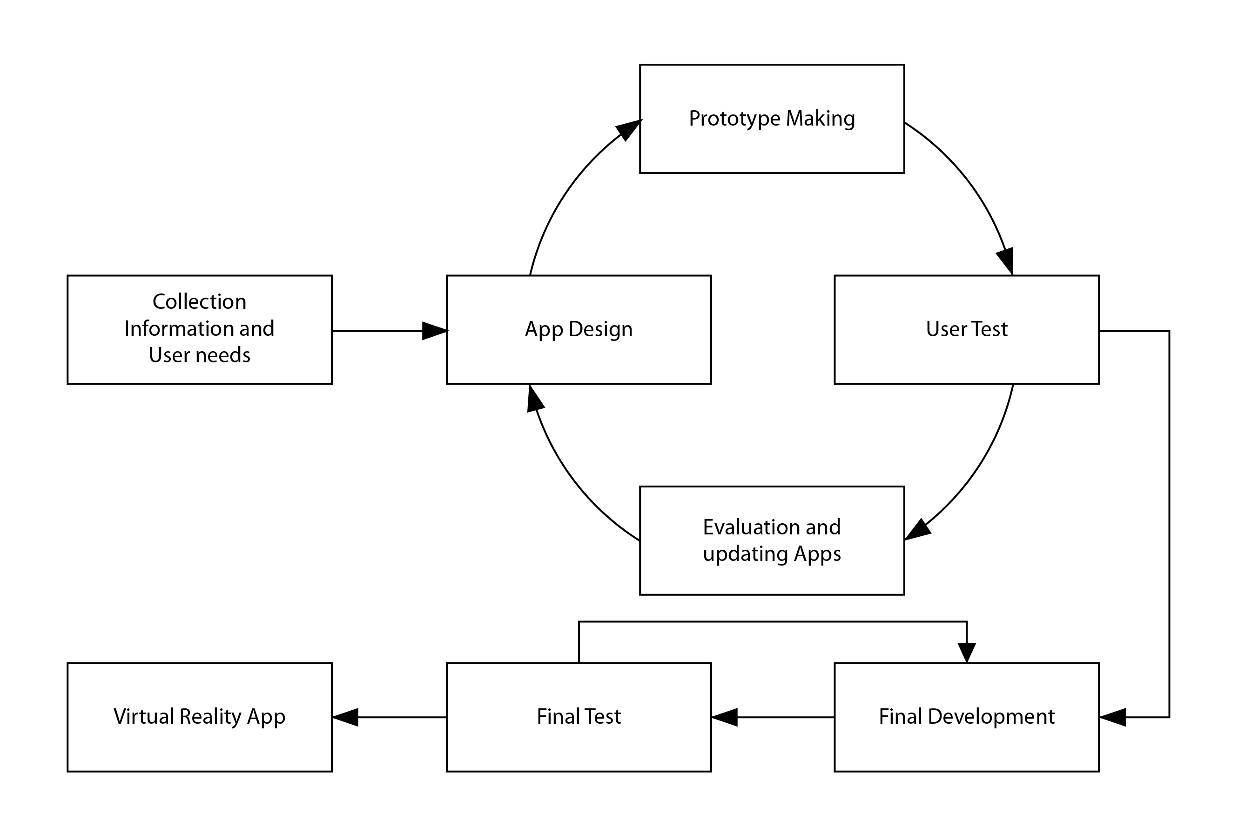
Figure 1. Research conceptual framework
- Application Conceptual Framework
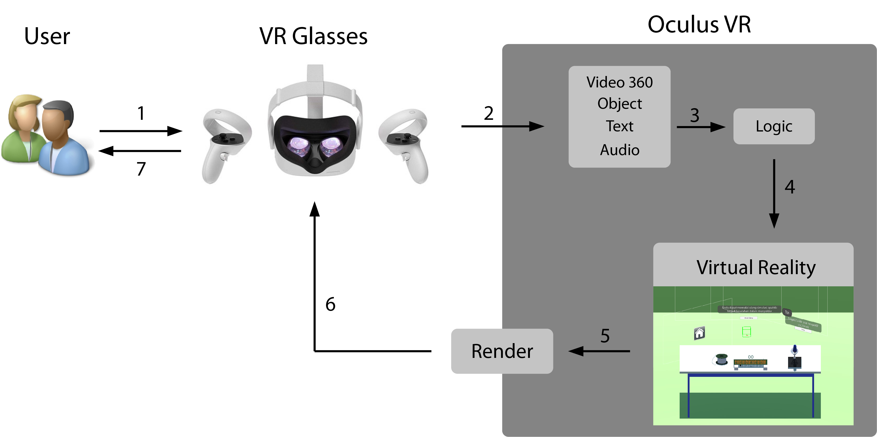
Figure 2. Application conceptual framework

- Application Design
- Application Flowchart Design
Application design begins with making a system flowchart to provide an overview of the flow design that exists in the program or system procedures logically.
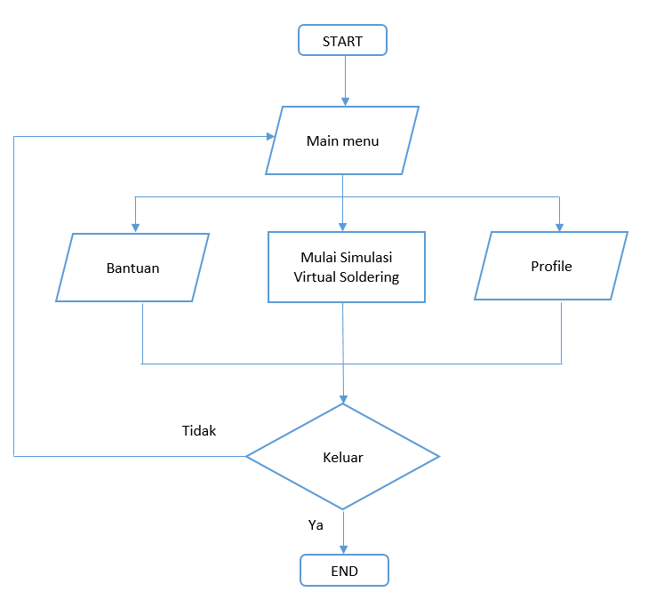
Figure 3. Application Flowchart Design
- 3D Modeling
At the 3-dimensional modeling stage, a design model of the equipment will be generated that will be used for practical work on the virtual soldering simulator. This modeling will be made using the Blender 2.91 program and then for the preparation of all 3D assets, it will be refined in the Unity3D 2019.4.16f1 program.
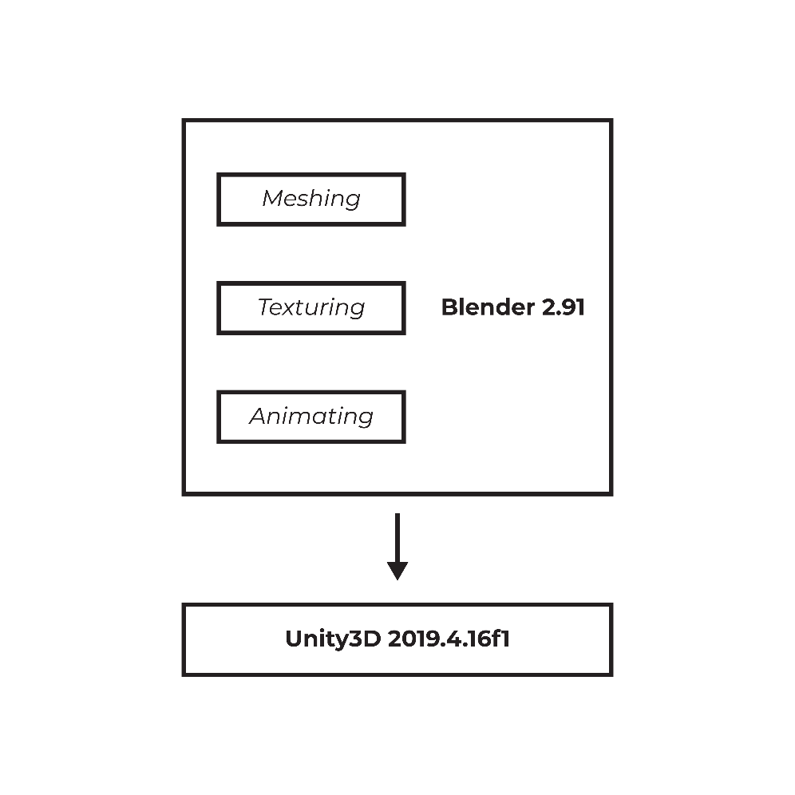
Figure 4. 3D asset modeling system using Blender 2.91
The 3D modeling system using Blender starts with the Meshing stage, which is the mesh object modeling stage. When the model has been completed, then proceed to the Texturing stage or the stage of presenting color and texture to each object by adjusting the texture on the game tool. The last stage is the Animating process, which is the stage of making animation from the model to simulate a certain process.
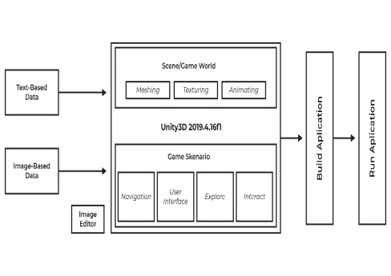
Figure 5. 3D asset modeling system using unity3D 2019.4.16f1
Modeling in Unity3D begins with the scene creation stage or commonly referred to as the game world, namely the stages in creating and managing a virtual soldering simulator. Setting the place makes the shape of the simulation room, then arranges the layout of the 3D model and the lighting settings. The game scenario is the next model by creating rules that will be used in the virtual soldering simulator. The rules are made in the form of user interfaces and interactions that can be done.
- Interface Design
The virtual soldering simulator interface is designed as attractive as possible so that it is hoped that users (users) will not experience difficulties and get their own experience in using this media:
- Initial Scene Design
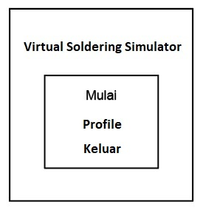
Figure 6. Front view design at the beginning of the scene
- Storyboard (App Design)
Storyboards or storyboards in application development are used to convey story ideas by combining visuals and narratives. The storyboard in this application describes the application flow, here is the storyboard in this application:
- Description
In Figure 5. there is information that must be found to find out the application design, namely "3D" explaining the 3D object of the Virtual Soldering equipment, "I" to display the tool information menu, "A" to return to the main page, "M" to return to the options menu simulation mode, “O” as the object where the player can move to that position, and “P” as the location/position the player is in.
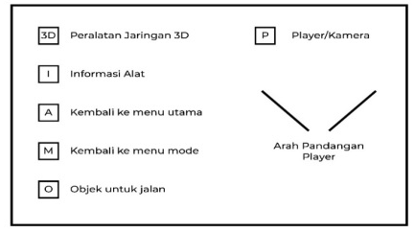
Figure 7. Description of storyboard
- Main page
The main page is located on the front side.
- Main page map
Figure 8. Main page map
Figure 6, is a map of the main page in which there are three menus from the front of the user. There is a title, start, profile, and exit. The direction of the player's view is first facing the front side, namely the starting title side. Front side concept start

- Front side concept start
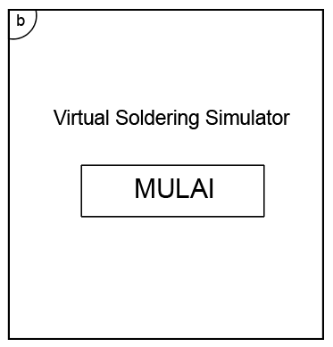
Figure 9. The concept of the front side of the main page
In Figure 7, the front side starts with the name of this final project application and the start button menu to start the simulation with a font color that is comfortable to look at and adjusts to the background.
- Front side concept Profile
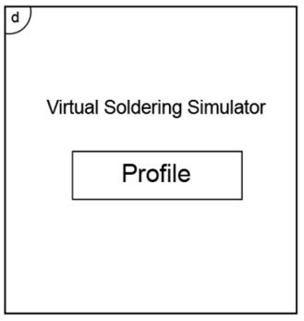
Figure 10. The concept of the front side of the profile menu
In Figure 8, on the front side of the profile, there is a profile menu that aims to provide information about the owner of the application maker with a font color that is comfortable to look at and adjusts to the background.
- Front side concept out
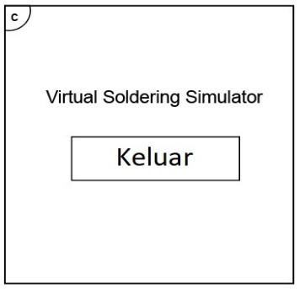
Figure 11. Front side concept exit menu
In Figure 9, on the front side there is an exit menu which aims if the player wants to exit the application, the player can select the exit button.
- Simulation Mode Page
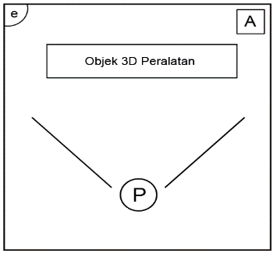
Figure 12. Simulation mode page
On this page, the player will enter a simulation mode wherein this player mode will be given instructions and instructions systematically related to how to start soldering. The initial view of the Player will show where the equipment will be used. From here, the player will be directed to take the equipment and start working according to the instructions, so that later the user can get used to the soldering process.
- Simulation Algorithm
The following is the algorithm of the simulation page with a flowchart.
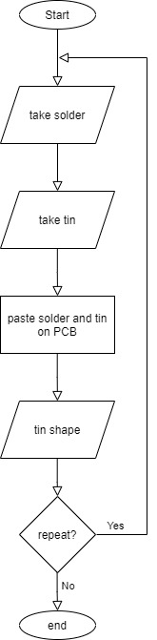
Figure 13. Simulation algorithm
- Program Algorithm
The following is the program algorithm used in the virtual soldering simulator that uses the C# programming language with the following flowchart:
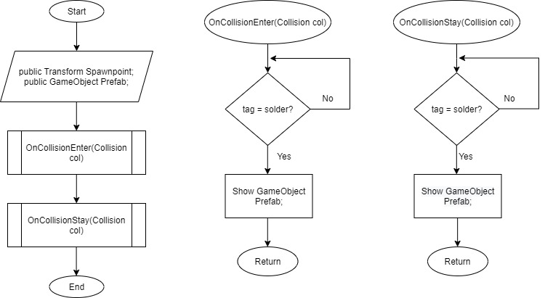
Figure 14. Program algorithm
RESULTS AND DISCUSSION
- Application Implementation
Implementation is the testing phase of the software design that has been made. This implementation is useful to find out whether the design virtual soldering simulator can run as desired.
- Development (Application Development)
Making the assets needed in applications such as 3D objects in the form of network equipment and information on walls to support the application of learning materials is the initial stage of making applications. Some of the processes for making assets in the Virtual Soldering Simulator Design and Construction application and the applications used are as follows:
- 3D Object Asset
Making 3D object assets in the form of equipment needed for soldering using blender software. The 3D object assets created include:

- Solder
- Printed Circuit Board (PCB)
- Tin
- Resistor
- Capacitor
- Integrated Circuit (IC)
- Table
Each 3D object asset that has been created will then be arranged in such a way in a room as shown in the following image: 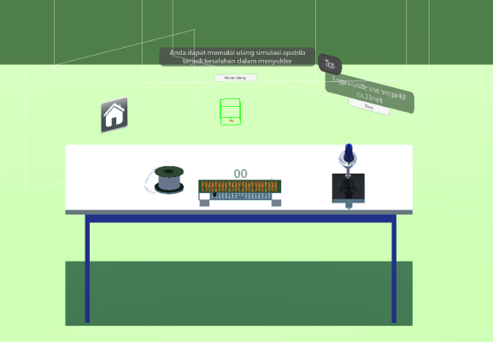
Figure 15. 3D object Asset
- Texture Results
A wide variety of textures are used in the creation of this application, for example, textures used in solders and solder holders, as well as other 3D object assets. Here's a look at the textures used:
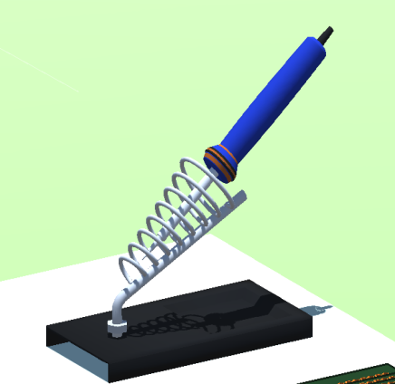
Figure 16. Texture solder
- Interface Design
- Home Page (Menu)
The start page is a page that displays the menu of the virtual soldering simulator application. On this page the player will select several menus, namely start VR, profile, exit.
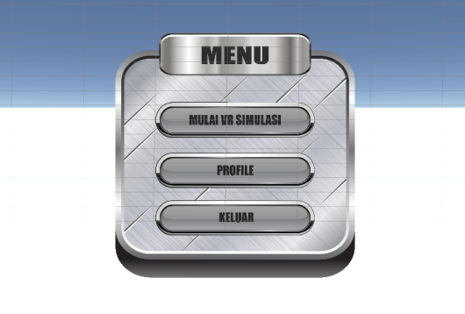
Figure 17. Menu display
The VR simulation start menu option is selected when the player wants to start the soldering simulation, where the player will enter the room to carry out soldering activities. The button profile is selected by the player if the player wants to know from the virtual soldering simulator application. The exit button is selected by the player if the player wants to exit the application.
- VR Simulation Start Page
The VR simulation Start page shows the player a room for soldering.
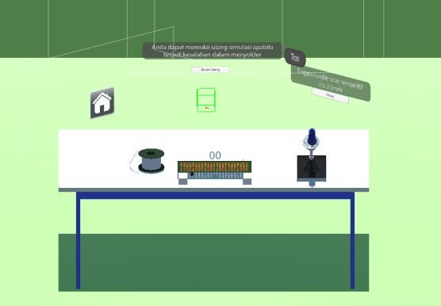
Figure 18. Simulation Page
Where the room is available for soldering equipment such as soldering iron, printed circuit board (PCB), table, tin, tips, and several menu options, namely restart and home. The restart button works if the player wants to re-stimulate in case of a soldering error. The home button functions if the player wants to return to the home menu.

- Simulation
The simulation will be carried out by the player, namely soldering. the player will take the solder and tin and then do the soldering on the Printed Circuit Board (PCB). Players are free to do soldering without having to be afraid of any mistakes because this application is a simulation.
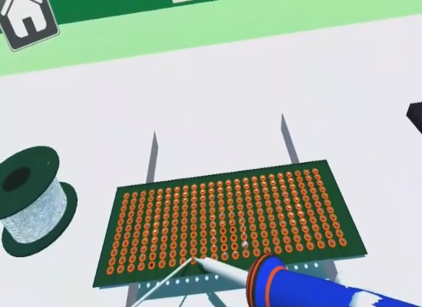
Figure 19. Soldering simulation
- Validation Results
- Media Expert Validation Test
Referring to the results of the material expert's assessment for the Virtual Soldering Simulator application which was developed from the aspect of media design, software, and benefits, then it got a score of 77.
After getting a material expert assessment score, it will be calculated using the following formula:
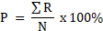
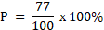
It can be seen from the calculation of the P-value above that the percentage result is 77%. Where the percentage states that the learning media made are "appropriate and do not need to be revised".

- Product Review
The resulting product is a Virtual Reality application as a soldering learning medium that has an app file format. This Apk file can be installed on an Oculus device with an Android OS with a minimum of API Level 23 or marshmallow, then run according to its use as a soldering learning medium. The deployment of this VR Soldering Simulator application is done using the help of share link Gdrive or other data sending applications running on Android devices.
This Virtual Reality Soldering Simulator application has the following advantages:
- The Virtual Soldering Simulator application can be used as a learning medium for anyone who wants to learn the basics of Soldering.
- Virtual Reality technology invites players to imagine without providing practical tools directly, only 3D animations of network equipment and virtual worlds appear as if they are on a network that is described as being seen.
- Virtual Soldering Simulator provides an experience like playing a game so that it will increase the user's desire to repeat.
- Players don't need to worry about unwanted things when soldering because in this application the player is free to do any soldering and if the player makes a mistake, just select the restart button and the simulation will return to normal.
Weaknesses of the Virtual Soldering Simulator Application include:
- To run the application still requires oculus quest hardware.
- Some 3D objects such as tin have not been used physically, as the result is still limited to 3D Hard Surface objects and is still rigid
- Just learn the basics of soldering.
- Discussion
At the analysis stage, several analyzes were carried out including system requirements analysis and material analysis. This stage is carried out by reviewing the needs in making applications and reviewing relevant theories by referring to the Basic Competencies of Vocational High Schools.
The design phase is carried out by designing a Virtual Reality application by designing an application flowchart, 3D modeling, interface design, storyboards, and scripts as guidelines in the process of creating a Virtual Reality application. The results of this design are then implemented into making the Virtual Soldering Simulator application. Every 3D object asset is designed using the blender application, the researchers chose to use the blender software because the blender is open source and quite easy to understand each tool. The Virtual Reality application itself is designed using Unity software which is supported by a special plugin for VR, namely the XR Interaction Toolkit which helps in adding scripts to both movement and physical objects. After the design is complete, the next stage is the development stage.
The development stage includes the stage of compiling the interface that has been designed previously. Then the stage of creating 3D object assets and coding programs for the Virtual Soldering Simulator application. From the coding stage, it produces software in the form of a Virtual Soldering Simulator application which has been equipped with various interesting features such as video display, object grab, and 3D simulation and animation. Then the Virtual Reality application is carried out in the testing phase. Testing is only limited to media expert validation to obtain initial test results. The next stage is to make improvements according to suggestions and directions from media experts. As for the suggestions and inputs are given by media experts, namely the placement of colors on 3D assets is still not effective and the back environment should not be allowed to see through. After being assessed by media experts, the Virtual Soldering Simulator application was developed under the criteria of "appropriate and without the need for revision" with an overall average score of 77% so that the Virtual Soldering Simulator application meets the validity aspect.
CONCLUSION
Virtual Soldering Simulator based on virtual reality can be an alternative in learning soldering devices. especially for people who want to learn independently to help reduce the risk of work accidents in learning soldering. This application is made using Unity software as a game engine and Blender as a 3D asset. Experiments and evaluations were carried out by 1 media or application expert. In an experiment or evaluation involving media or application experts, from the aspect of media, software, and benefits, a score of 77 was obtained. Where the score stated that the application made was appropriate and suitable for use in soldering learning.
SUGGESTION
It is hoped that further researchers can add some simulation features, and it is still necessary to develop interaction between users and the features in 3D Modeling so that the Virtual Soldering Simulator feels more real.
REFERENCES
[1] R. K. Dewi, “Pemanafaatan Media 3 Dimensi Berbasis Virtual Reality Untuk Meningkatkan Minat Dan Hasil Belajar Ipa Siswa Kelas V Sd,” J. Pendidik., vol. 21, no. 1, pp. 28–37, 2020, doi: 10.33830/jp.v21i1.732.2020.
[2] M. Al, F. Yosfiah, and F. Prasetya, “PERANCANGAN MEDIA PEMBELAJARAN INTERAKTIF VIRTUAL REALITY PADA MATA KULIAH TEKNOLOGI PEMESINAN DI JURUSAN TEKNIK MESIN FT - UNP DESIGN OF VIRTUAL REALITY INTERACTIVE LEARNING MEDIA IN MACHINERY TECHNOLOGY COURSE IN MECHANICAL ENGINEERING DEPARTMENT FT - U,” vol. 4, no. 1, pp. 132–136, 2022.
[3] H. T. T. Saurik, D. D. Purwanto, and J. I. Hadikusuma, “Teknologi Virtual Reality untuk Media Informasi Kampus,” J. Teknol. Inf. dan Ilmu Komput., vol. 6, no. 1, p. 71, 2019, doi: 10.25126/jtiik.2019611238.
[4] F. T. Moura, “Telepresence: The Extraordinary Power of Virtual Reality,” Retrieved August, vol. 26, p. 2020, 2017.
[5] F. Oktafia and D. N. AN, “Persepsi Mahasiswa Sosiologi FIS UNP Tentang Mata Kuliah Micro Teaching dan Pelaksanaan Praktek Lapangan Kependidikan (PLK),” J. Sikola J. Kaji. Pendidik. dan Pembelajaran, vol. 2, no. 1, pp. 63–69, 2020.
[6] K. T. Martono, D. Eridani, and D. I. S. Isabella, “User experience pada Implementasi Virtual Reality sebagai Media Pembelajaran Anak Pengidap Autisme,” J. Politek. Caltex Riau, vol. 6, no. 1, pp. 1–11, 2020.
[7] H. T. Putro, “Kajian Virtual Reality,” Makal. Stud. Mandiri Univ. Teknol. Yogyakarta, Januari, 2015.
[8] H. A. Musril, J. Jasmienti, and M. Hurrahman, “Implementasi Teknologi Virtual Reality Pada Media Pembelajaran Perakitan Komputer,” J. Nas. Pendidik. Tek. Inform., vol. 9, no. 1, p. 83, 2020, doi: 10.23887/janapati.v9i1.23215.
[9] P. Anggoro, “Kajian Interaksi Pengguna untuk Navigasi Aplikasi Prambanan VR Berbasis Virtual Reality,” J. Teknol. Inf. dan Ilmu Komput., vol. 239, 2018.
[10] W. Muldayani and I. Fibriani, “Kontrol Adaptasi PID pada Solder Oven untuk Komponen SMD.”
[11] I. Hermawan, “E-Learning Berbasis Virtual classroom di Era Covid-19,” vol. 1, no. 1, pp. 1–10, 2020.
[12] B. Sihite, F. Samopa, and N. A. Sani, “Pembuatan Aplikasi 3D Viewer Mobile dengan Menggunakan Teknologi Virtual Reality (Studi Kasus: Perobekan Bendera Belanda di Hotel Majapahit),” J. Tek. ITS, vol. 2, no. 2, pp. A397–A400, 2013.
[13] I. Kurnia, “3D Pupper Making Virtual Museum Using Virtual Museum Virtual Reality Modelling Language 97 (VRML97) As Part Of The Pupper Museum Website: dalam internet,” Depok Gunadarma Univ. Libr., pp. 1–3, 2013.
[14] S. Vidiardi, “Pengembangan museum virtual interaktif menggunakan teknologi desktop virtual reality pada museum Ranggawarsita.” UNIVERSITAS NEGERI SEMARANG, 2015.

